JSC “NPG Granit-Salamandra”
Generator of extinguishing aerosol AGS-11/3

PASSPORT

INFORMATION ON THE PRODUCT:
Generator AGS-11/3 batch No_______________
Aerosol forming compound batch No _______________
Date of manufacturing _______________________
Starter type_________ batch_______

MAIN TECHNICAL CHARACTERISTICS:
Semi-hermetic protected volume 6.0 m3
Warranty period – 18 months, including 12 months of storage.
Operating life – 5 years, including 1 year of the storage
Lifetime – 10 years
After expiration of the operating period the question of its prolongation can be solved by the Manufacturer.

COMPLETENESS OF THE PACKAGE:

Generator AGS-11/3
Instruction Manual with passport
Generator conforms to Technical Conditions 4854-110-54876390-2003
The packing conforms to the requirements of engineering documentation

Department of technical control

Address:
JSC :NPG Granit-Salamandra”
Izhorskaya str., 13/19 125412 Moscow
Tel: 485-8454, 485-9827

JSC “NPG Granit-Salamandra”

INSTRUCTION MANUAL
For the extinguishing aerosol generators
AGS-11/3

VEPK.634239.11.3 RE

Moscow, 2000

- APPLICATION
Generator of extinguishing aerosol AGS-11/3 (hereinafter – generator) is the mean of volume fire extinguishing is designed for localization and suppression of fires of solid combustible materials (wood, insulating materials, plastics etc.), inflammable liquids (petrol, oil refinery products, organic solvents, etc.), electrical insulating materials and electrical live equipment with voltage up to 40 kV. It can be used for fire extinguishing in the rail road transport.
Generators should be used in accordance with the valid norms (SP 5.13130.2009 “Automatic fire alarm and fire extinguishing systems”)
Generators are not applied for extinguishing of alkaline metals, as well as for extinguishing of substances which are burning without air access.
- DESIGN OF GENERATOR AGS-11/3
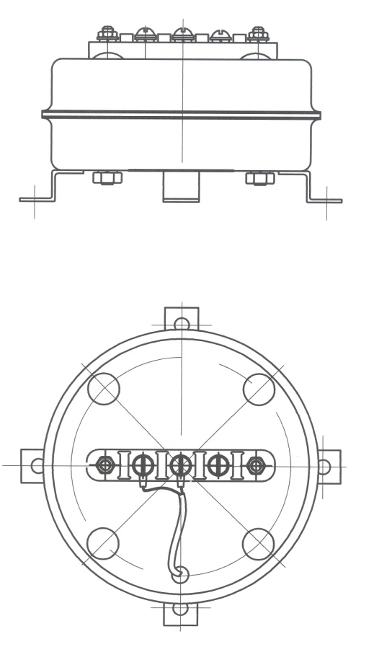
Generator (see the drawing) consists of the body inside which an aerosol forming compound is located. Aerosol forming compound is separated from the shell of the body by the heat insulating material. The starter is installed inside the generator body and is connected with terminal located on generator body.

- PRINCIPAL OF OPERATION
The principal of generator operation is based on the inhibiting of oxidation-reduction reactions by the highly dispersed product (aerosol) of alkali metals salts and oxides which can stay suspended for a long period. After the electric or heat impulse reaches the starter, the aerosol forming compound is ignited. Aerosol is produced in the process of burning of the solid aerosol forming compound which is located inside the generator shell. Aerosol flow penetrates through the cooler and enters the protected volume.
After generator starts its operation concentration of the oxygen in the protected room remain almost the same.
The settled aerosol can be removed from the different surfaces with the wet cloth or vacuum cleaner.
- TECHNICAL CHARACTERISTICS OF GENERATOR AGS-11/3
Mass of generator: 1.34 + 0.05 kg

Mass of aerosol forming compound: 0.3 +/- 0.01 kg

Aerosol extinguishing ability 0.05 kg/m3

Maximum volume of protected semi-hermetic room (δ < 0.001 m-1*): 6.0m3
*) δ – is ratio of the total area of the openings to the volume of protected room

Operating period: 15 - 26 sec

Dimensions (without brackets):
- Diameter 135 +/- 2 mm
- Height: 52+/- 2 mm

Operating conditions:
- Temperature from – 50 °C to + 50 °C
- Relative humidity up to 98%
- Mechanical effect 2 g in the frequency band up to 10 - 260 Hz
- Size of zone with temperature over 400 °C 0.05 m
- Size of zone with temperature over 200 °C 0.15 m
- Size of zone with temperature over 75 °C 0.5 m
- Size of fire hazard zone 250 mm
- Maximum temperature of generator body does not exceed 150 °C.

Characteristics of electrical signal necessary for the start up of generator and for control of electric starting chain during operation of generator as part of aerosol fire extinguishing system:

Electrical starter UZT-7,5 (is installed inside):
- Voltage – 12 – 24 V
- Minimum starting current – 1.0A
- Type of current – direct (DC)
- Duration of impulse – not less than 1.5 sec
- Resistance of electrical initiator of the starter –7.5 – 8.0 Om (without additional resisters)
Maximum current of control of generator starting chain should not exceed:
- At constant control – 0.005 A
- At periodical control during no more than 2 minutes with breaks not less than 10 minutes – 0.05A.

Electrical starter UZ-7,5 (is installed inside):
- Voltage – 12 – 24 V
- Minimum starting current – 1.0A
- Type of current – direct (DC)
- Duration of impulse – not less than 1.5 sec
- Resistance of electrical initiator of the starter –7.5 – 8.0 Om (without additional resisters)
Maximum current of control of generator starting chain should not exceed:
- At constant control – 0.005 A
- At periodical control during no more than 2 minutes with breaks not less than 10 minutes – 0.05A.

The starter type should be chosen by the Buyer.

Heat quantity which is distinguished during generator operation: 1029 kJ

Composition of products of burning:
Component | Concentration, mg/m3 | Volume fraction, % | Concentration, mg/g relatively
NH3 | 25 | 0.0037 | 0.256
NO2 | 11 | 0.00061 | 0.112
HCN | 13.5 | 0.0012 | 0.136
CO | 460 | 0.04 | 4.62
CH4 | 196 | 0.03 | 1.97

Mass composition of the dispersed phase:
2K2CO3*3H2O 52.7%
KH4HCO3 25.7%
KHCO3 8.2%
KNO3 7.9%
Other 5.5%

Generator keeps its integrity and efficiency and does not spontaneously start after the free fall from the height of 1 m on the concrete layer with the thickness not less than 100 mm or on the steel sheet with the thickness not less than 16 mm.

According to GOST 19433-88 generators are not the hazardous cargo and should not be specially marked.
Electrical resistance between generator body and terminals for connecting of the starting chain at the normal climatic conditions should be not less than 1 MOm (according to GOST 15150-69).

The value of ozone depleting potential of aerosol does not exceed 0.01.

- DEFINING OF THE NECESSARY QUANTITY OF GENERATORS AGS-11/3 AND THEIR ALLOCATION IN THE PROTECTED ROOM

  - The design and installation work on aerosol fire extinguishing systems should be fulfilled by the specialized organizations which have the license for such type of service.
  - Calculation of generator quantity necessary for protection of the given room is made according to the methodology contained in the valid norms.
  - Generators are recommended to be installed in such way to provide quick and even filling of the protected room with the aerosol and to minimize aerosol outflow through the openings (hatches, gates, ventilation etc.) .
  - Aerosol flows should not be directed towards the openings and towards equipment, wiring, property, electrical appliances located nearby. The distance to the nearest equipment should be defined in accordance with temperature zones created around operating generator and with fire hazard zones.
  - The distance from generator to the fence or wall, to the equipment, wiring, electrical appliances should be not less than 500 mm.
  - Generators can not be installed on the burning basement;
  - There should be an access to installed generator for control and prevention works;
  - If several generators are used for protection of one space, their simultaneous activation should be provided;
  - The forced shutdown of ventilation in the protected room should be provided before generators activation.

- PREPARATION OF GENERATOR FOR OPERATION AND ITS ACTIVATION

Before installation of the generator at the designed place it is necessary:
- To check the integrity of the packing;
- To open the package, take out generator, Instruction Manual and the passport;
- To check completeness according to the passport;
- To compare information on generator, on the packing and in passport;
- To check the integrity of generator and wires of the starter;
- To check the starter integrity using multimeter (to measure the resistance, it should match with value in the passport);
- To check resistance of insulation (by connecting alternately each starter wire to generator body);
- Before connecting generator to the starting chains it’s necessary to make sure that there is no voltage.

- ACCIDENT PREVENTION DURING INSTALLATION AND OPERATION

  - During work with generators and starters it should be considered that they contain the inflammable compositions
  - During installation of electrical starters the endings of cables should be shorted. Their connection to the jack on generator should be done after commissioning of the whole automatic fire extinguishing system.
  - Electrical equipment of premises in which generators with electrical starters are installed should conform to requirements of Rules of Electric systems operation.
  - At the design of generator electrical starting chains there should be provided the measures which exclude the appearance of current pickup which can lead to the accidental start of generators.
  - When fire starts and generators are activated, people located in the premises should leave it rapidly, close the doors and call fire brigade.
  - In is not recommended to use generators in the premises which can not be abandoned before generators start their operation.
  - If it is impossible to leave the room quickly, the respiratory should be protected from the impact of the aerosol particles with the fabric bandage or gauze.
  - It should be kept in mind that during generator operation the temperature of aerosol flow at a distance of 0.5 m from generator is up to 75 ⁰C, 0.15 m – 200 ⁰C and 0.05 m – 400 ⁰C. The cover and bottom of generator can reach the temperature of 200 ⁰C .
  - After generator has been activated its is necessary to remove the products of burning and the settled aerosol from the surfaces within 3 days, because aerosol is hygroscopic and has a week alkaline reaction after moisture absorption. This can cause the oxidation of nonferrous metals. The cleaning is done with the brusher vacuum cleaner and the wet cloth. If the electrical appliances are located in the protected room, it is recommended to cover it with dust protective shell.

IT IS FORBIDDEN:
- To use generators for manual extinguishing of fire;
- To make the welding at a distance less than 3 meters from generator;
- To use damaged generators;
- Dismantle the generator.

- MARKING, PACKING, STORAGE AND TRANSPORTATION OF GENERATORS AGS-11/3

  - There are serial numbers of aerosol forming compound, generator, manufacturing date, mass of compound and maximum protected volume in the passport and on the label of generator.
  - Generators AGS-11/3 are supplied by the Manufacturer packed into the pasteboard boxes.
  - Generators and starters in Manufacturer’s packing can be transported by all means of transportation.
  - Generators should be stored in the Manufacturer packing in the closed storage rooms under the temperature from +5°C to +40°C and relative humidity up to 80% without the presence of aggressive environment.
  - Generators can be stored in a pile, but no higher than 5 stages one on another (according to the Manufacturer packing)

